# 1: Can you store different types in an array in c#?

Yes. By creating an array of type “object” we can store different types in an array. Like we create an array of type “int” we can only store int values int it. In array of type object we can store all values be it string int or even object of some class.

For ex: object[] arr = new object[2]; **Correct**

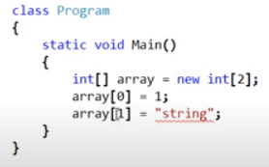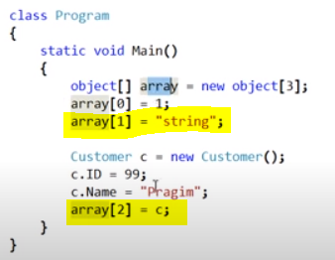

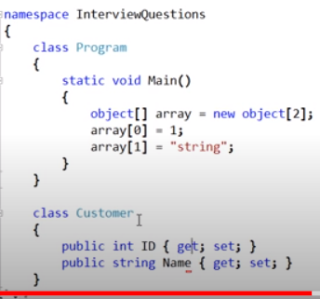

In snapshot 2 we have assigned string value and we have even assigned an object of class customer.

# 2. Why and when should we use an abstract class?

Ans: We would create an abstract class when we want to move the common functionality of two or more related classes to a base class and we do not want to instantiate that base class. We made it abstract as we do not want developers to accidentally be creating instances of that base employee abstract class.

Let’s understand this with help of an example. Let’s say an organization have to Employees.

1. **Fulltime Employee and Contract Employee. We created class for each of the two types of employee.**

# Now as you can see few variables and functions are common in both the classes.

# What we can do is we can add common functions to one base class and work with it. Here we have not yet made that base class as abstract. Let’s see what can be disadvantage of not making the base class as concrete and not the abstract class.

# 

# Here we created a concrete base class (non-abstract) which has the common variables and function od both classed. As you can see we have not yet made it abstract.

# 

# 

# Now Base class is available to devloper and they can create it’s instance.Where as the requirement is that common features should be added to base class and as the org has only two employees so the object should be created only for *Fulltime Employee and Contract Employee.*

# *But there is nothing stopping us from creating the object if base class.*

# So now if we make our bas class as abstract.:

# 

Important:

1. It does not allow us to create an instance of/object of base class. If we try **to create an object of abstract base class it will give compilation error.**
2. And by creating GetMonthly salary function as abstract we forced the derived classes to have a GetMonthly salary method in it. If they do not **have it will give error on compilation.**
3. The abstract class may or may not have abstract methods but If a class has even one abstract method then the class must be marked as abstract. Or the class is abstract.

# 3.What are the advantages of using interfaces?

# 

# 

# Abstract class virtual method

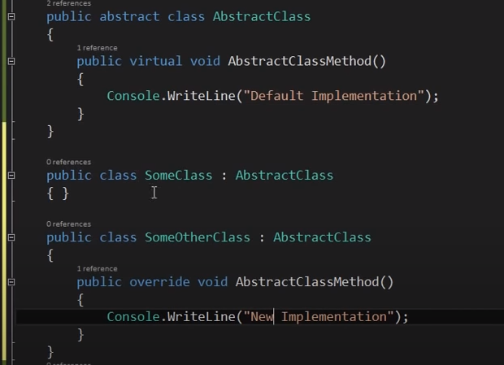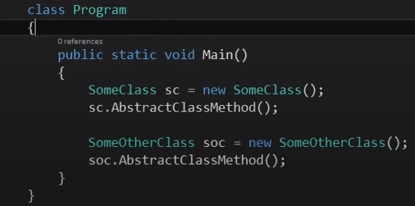

It is a standard that tells developer to redefine the function in some derived classes and no need to redefine in other.

# 5. Real time example of recursion

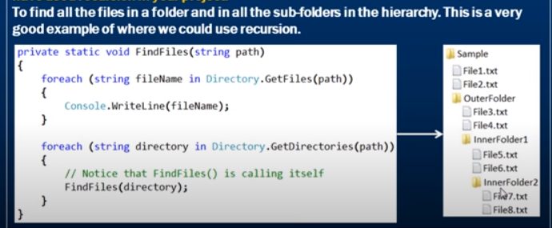

# 6. Storing different list types in a single generic list

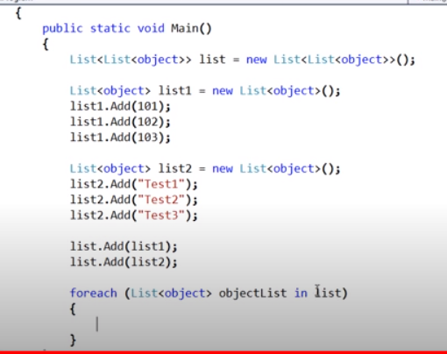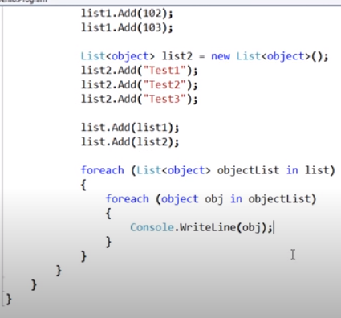

# 7. Can an abstract class have a constructor?

# 1. Yes, Abstract class can have a constructor. It helps to initialise the fields of the abstract class.

# 2. If we create the constructor of derived class on creating the object of derived class first the constructor of abstract class is called and then the constructor of derived class is called. (You can debug and see).Therefore we have the constructor for abstract class when we need certain fields of abstract class to be initialised even before the instantiation of child/derived class takes place.

# 3.Although we cannot create object of abstract class then why is the constructor of abstract class needed because when we create the object of derived class the constructor of base class is automatically called as stated in point2.

# 4. It’s good practice to mark the constructor in abstract class as protected as “public “ access control modifier doesn’t make any sense. (as we know we cannot make the object of abstract classes.)

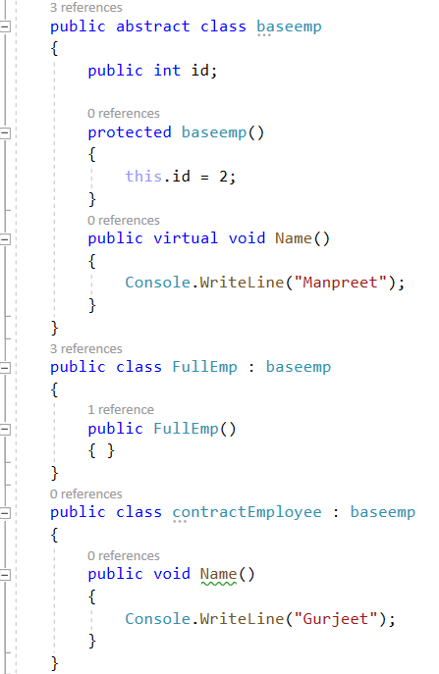

# 8. Call an abstract method from an abstract class constructor

# Yes.

# 

# 

# 9. What happens if finally block throws an exception? Or How to handle exceptions that occurs in finally block?

# 

# If the exception occurs in finally method it needs to be handled in main method as shown in pic 2,else the application will crash.

# The finally block execution stops where the exception is occurring, if there is any line of code statements after the int result = Convert.ToInt32(“Ten”); will not be executed.

# Third imp point is if any exception occurs before finally block say in try block and it is not handled then try block exception is lost.

# 

# 8. What is the difference between is and as keyword in c#.

# 1. is keyword works like equal to say if the emp is the object of type employee it returns true else it returns false.

# 2.

# 

# 9. What is the access modifier of default constructor?

# Ans: Public

# 10. Asyn and await in c#.

# When we used Thread.sleep our app became unresponsive till the processing of file was done.

# On using async and await the our application becomes responsive. Till the reading/processing of file is being done we can ,move the dialogue box resize it and all that we couldn’t use using thread.sleep.

# Await says it’s suspention point. The await operator signal that async method can’t continue past that point until that process is complete.

1. It can be achieved Using thread but code becomes complicated and painful.

# 

11. Output of this is // 1,3,5,7,9,11,13 PreIncreement

for (int i = 0; i < 13; i++)

{

Console.WriteLine(++i); // 1,3,5,7,9,11,13

}

12. Output of this is //0,2,4,6,8,10,12 PostIncreement

for (int i = 0; i < 13; i++)

{

Console.WriteLine(i++); // 1,3,5,7,9,11,13

}

13. Console.WriteLine(2+5+"7"); //77

Therefore + operator between tow integer add and between int and string concatenates.

14.Important:

-> Array's are passed as an object by ref. Therefore, any change in myArray(inside bubble sort function) also changes the actual myArray.

-> Changes done to myArray in a function modifies the original myArray.

int[] myArray = { 5, 7, 7, 2, 4, 1 };

objPQ.bubblesort(myArray); // o/p

Console.WriteLine();

foreach (int a in myArray)

{

Console.Write(a + "<--");

}

15. When we initialise an object of the derived class it automatically calls the constructor of base class.

**O/p ->**

**Hello Motu**

**10**

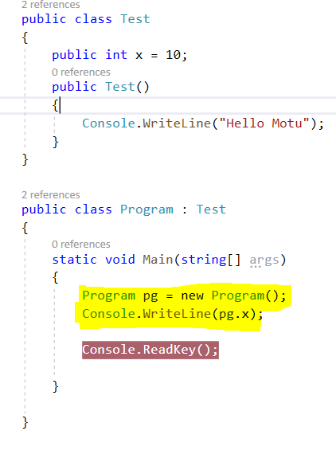



16. If we create the object of derived class, then out of the base class and derived class’s constructor, first the base class constructor is called and then the derived class constructor is called.

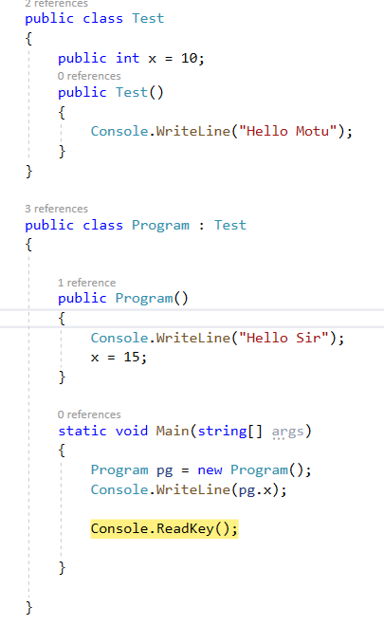 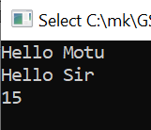

17 Always remember ,the calling hierarchy Base class-> Program->Another->Mainj

First the *base* class is called then base class of *another* then *another* then *main*.

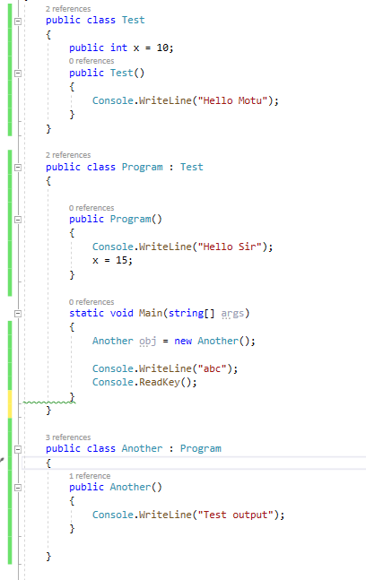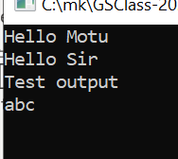

18

. 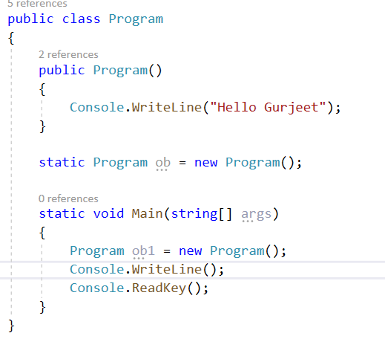

o/p

Hello Gurjeet

Hello Gurjeet

19. When a class loads then all the static things runs first. Therefore Line “Program ob = new Program()” is executed when marked as static but not executed if not marked as static because it does not lie in any fuction.

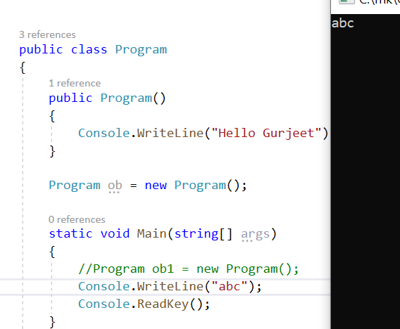

20.Static thing will always be loaded first when the class is loaded and then so on..

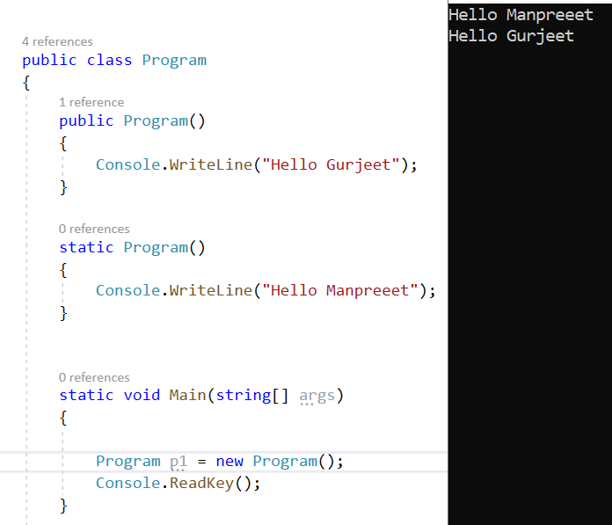’

21.

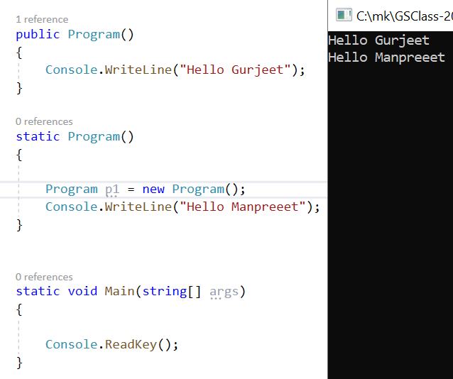

22. Compiler will look for specific class if it does not get it only then it will go for super class i.e. object class

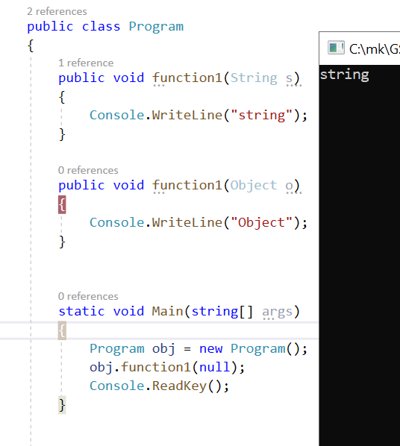

**23. Constructor**

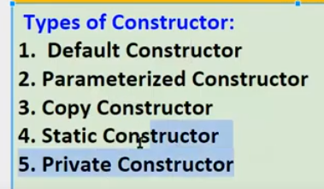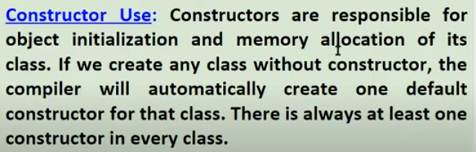

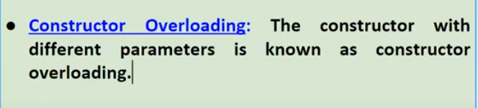

**Constructor Overloading ex below:**

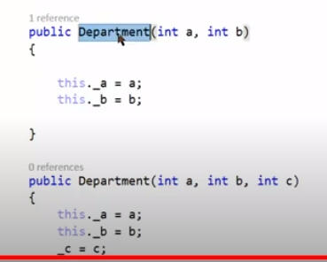

**24**



If we do not specify a default construct then the build will be successful so it is not mandatory however if we write **Department dd = new Department().** Then it will give error as there is no default constructor mentioned**. So if we wish create the object of the class with no parameters then it is necessary.**

**So as**

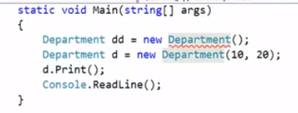

**25.**

**25.**

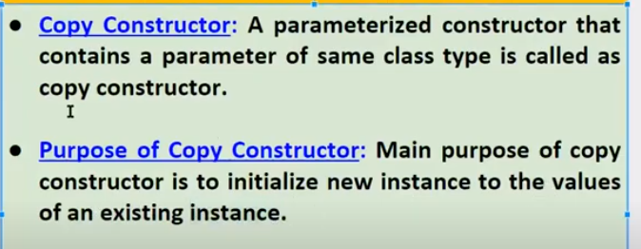

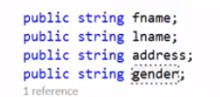

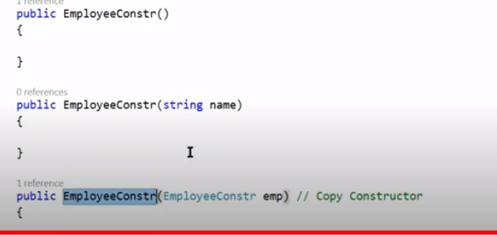

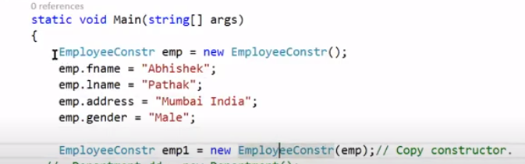

The above example also explains Passing object as **call by value.**

Had we done **– *emp1= emp*** -> This was **object by refernce**. That is any change in

**Emp1.fname=”Manpreet”** would have modified **emp.fname to Manpreet** as well. Because we did

***Emp1=emp***

**26.**

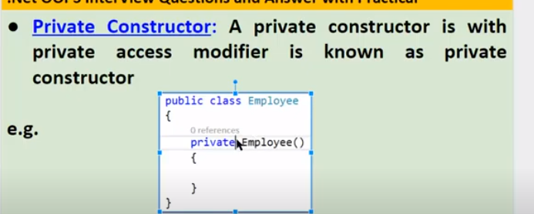

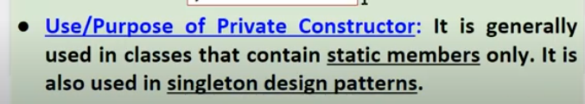

If we have Private constructor:

* We cannot have default constructor if we have private constructor without parameter. As we know both will have same name and no arguments.

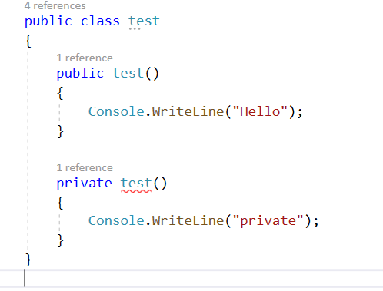

* If there is only private constructor then we cannot create the object of that class

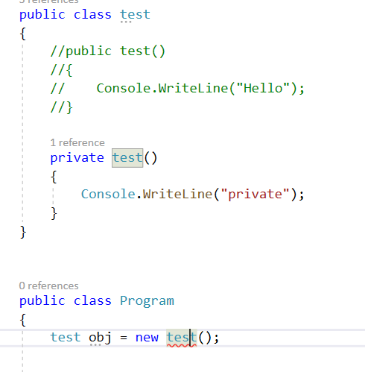

* We can have default constructor if the private constructor is parametrized. In this case we can create the object of the class as well.

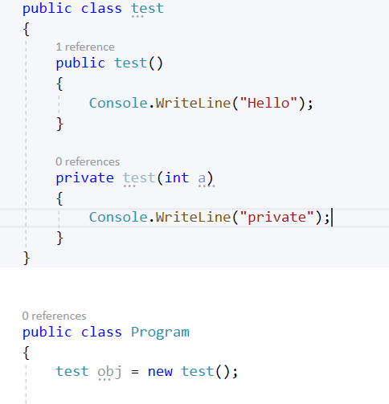

* If there is only private constructor in the class which (non parametrized) because of this we cannot have default constructor so we cannot create the object of the class and class cannot be inherited as well.

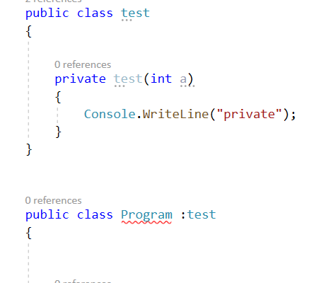

**Important**  So what is the use of having just private constructor in class when we cannot create the object or inherit that class. It is used when the class has only static members. As to access static members we do not need to create the object of that class

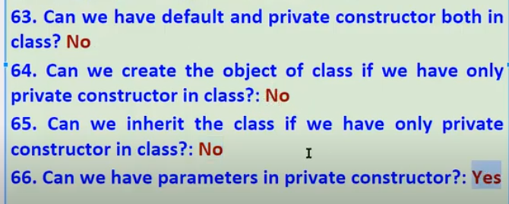

27.

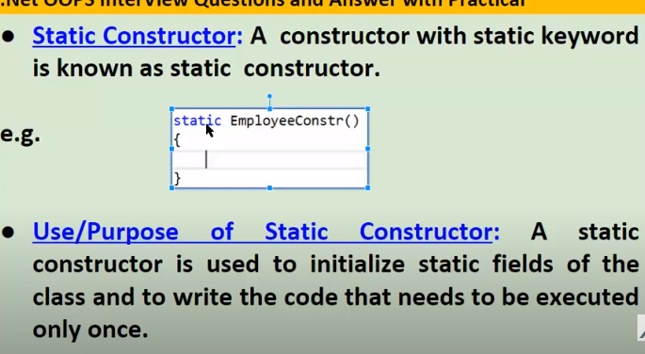

* Static constructor cannot have access modifier.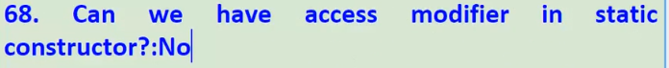

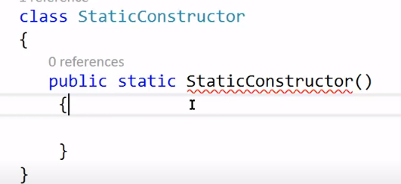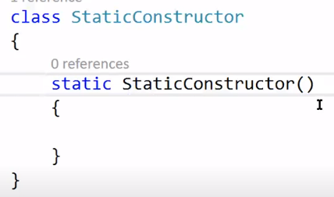

* Static constructor cannot have paramters.

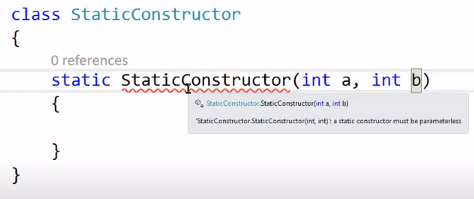

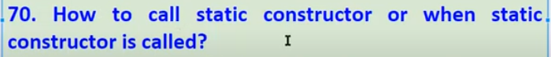

* When we create the **first instance** of class. Static constructor is called exactly once



* Only once

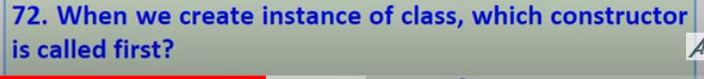

* Static constructor
* And it is called exactly once.

For ex: As we have create two object of class. First time i.e. on creation of first object the first static constructor is called then -> default constructor is called.

On creation of second object only default constructor is called as static constructor is called exactly once.

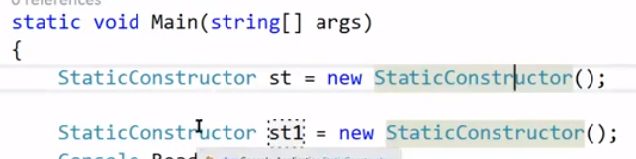

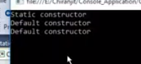

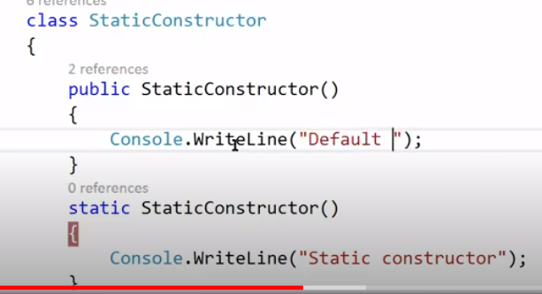

* 

Yes.

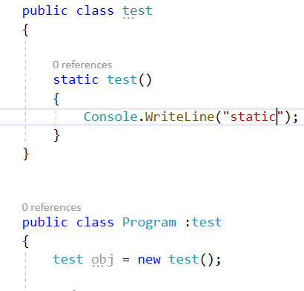

* **Use of Static constructor.**

If we wish to initialise static variables we can do so in static constructor. We can initialise static variable in default constructor as well but we do so in static constructor **if we want it to be initialized exactly once.**

Imp: We cannot initialize normal variable in static constructor.

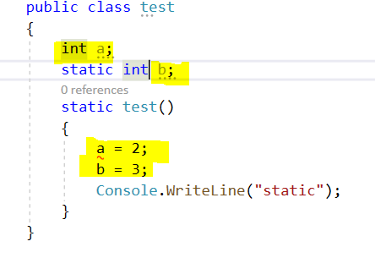

28. 

We can do so by using “this” key word.

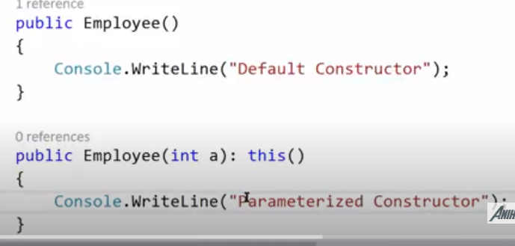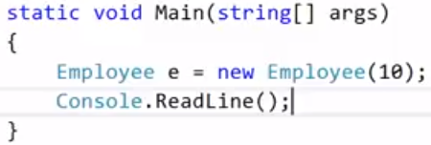

Here due to “this” keyword it will first call the default constructor and then call the paramterized constructor.

If we want the order as first – the parametrized constructor then default constructor we can do this :

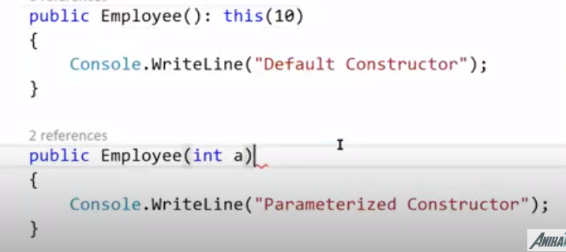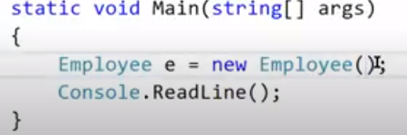

29.

Here Super Employee is the base class. We can memorize this by “CP” which says left side is child class and right side is base class.

Now When we create the instance of Employee class first the Base class constructor is called automatically then the child class constructor is called. (as we know ).As we have not used any keyword and it happens automatically it is called **Implicit call.** Now in next point we will discuss how do we explicitly call the base class constructor.

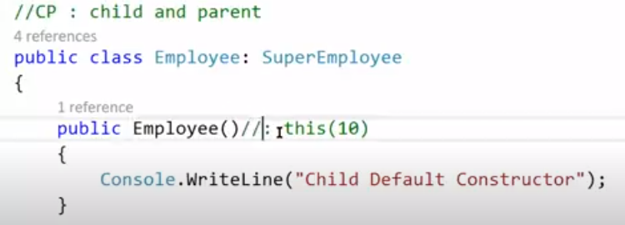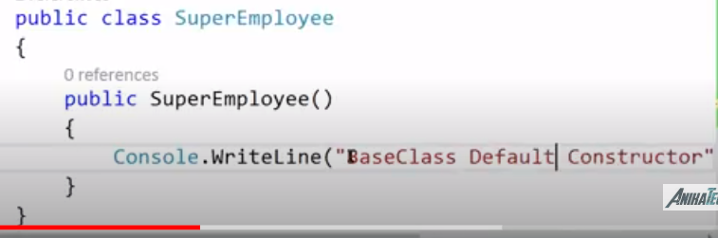

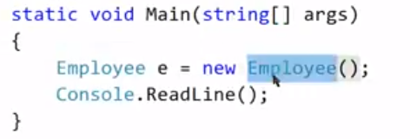

30. 

Explicit call is mad by using base keyword in child class constructor.

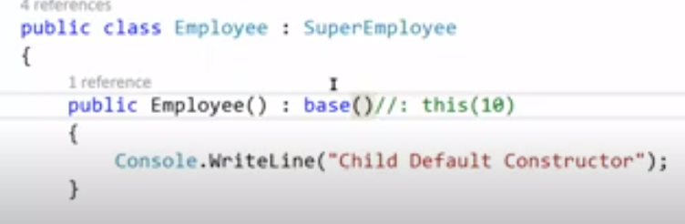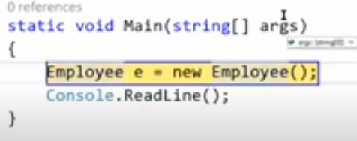

31. 

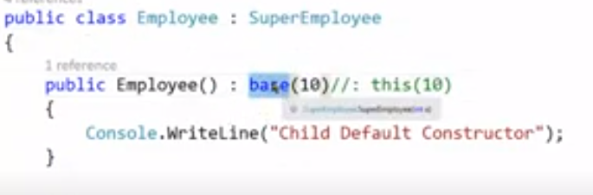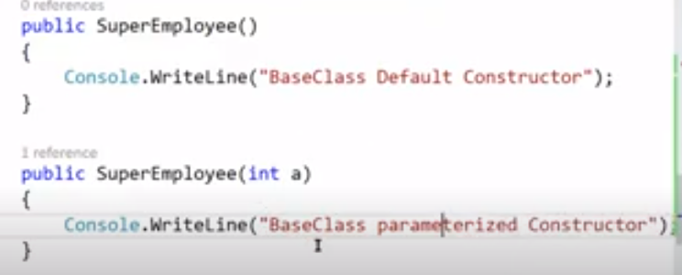

Here first base class paramterized constructor will be called and then the child class constructor will be called.

Employee = new Employee();

o/p->

BaseClass parametrized constructor

Child Class Constructor

32.

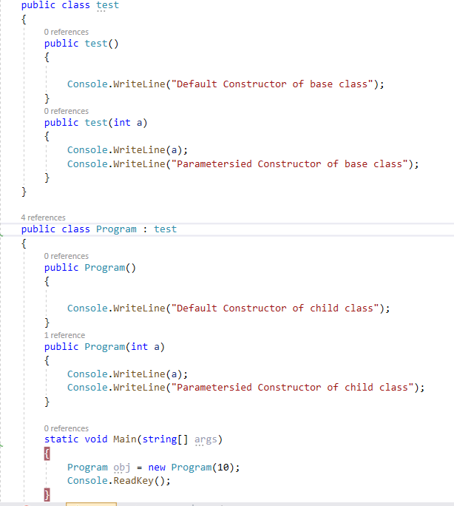

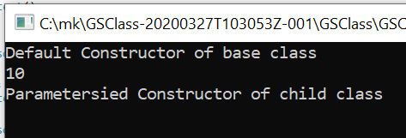

Here first base class default constructor is called then child class parametrized constructor is called.

Now if we want that instead of base class default constructor base class parameterized constructor should be called then we can use base keyword,

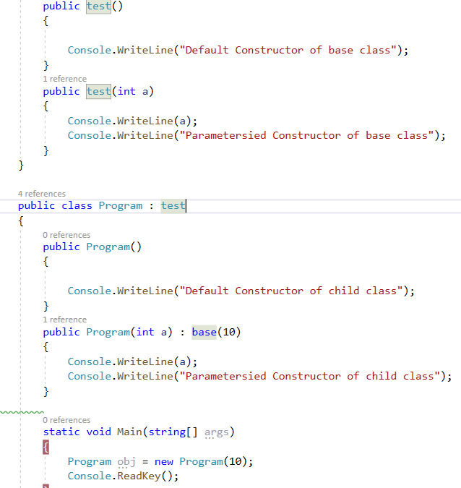

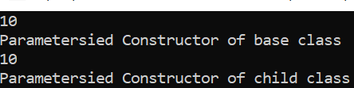

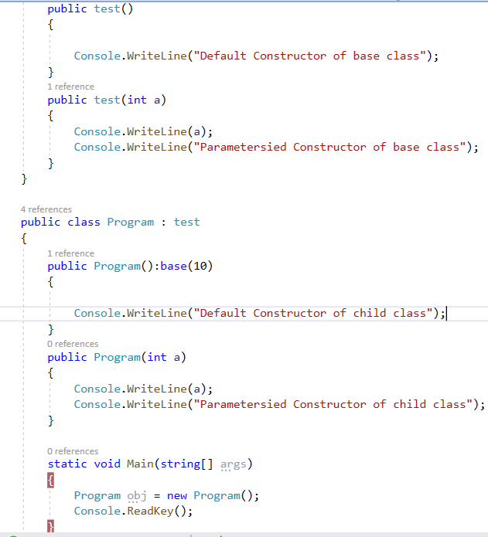

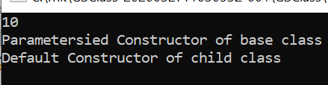

So now we can conclude that we know each time we create the object of child/derived class, First the base/parent class constructor is called and then the child class constructor is called.

So we can memorize it in this way:

1. **Program obj = new Program();** -> Now this line means that program class object is created now when we go to program class there will be constructor.

if there is:

* public Program() -> If this is written then base class default constructor will be called. and consequently derived class default constructor
* public Program():base(10)-> If this is written then base class parameterized constructor will be called and consequently derived class default constructor

1. **Program obj = new Program(10);** -> Now this line means that program class object is created now when we go to program class there will be constructor.

if there is:

* public Program(10) -> If this is written then base class default constructor will be called. and consequently, derived class parameterized constructor
* public Program(10):base(10)-> If this is written then base class parameterized constructor will be called and consequently, derived class parameterized constructor.

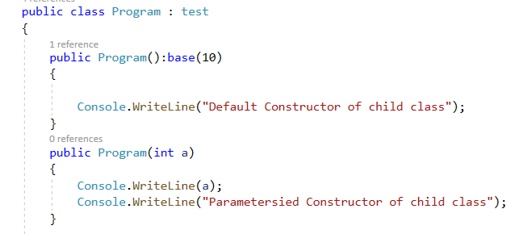

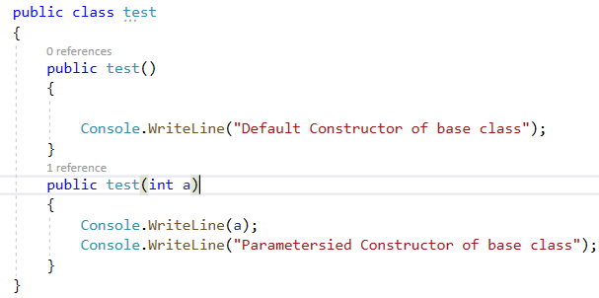

33.



1. pic 1-Note if there is no default class constructor and only parameterized constructor in base class then it will give error while writing only.
2. Pic2- If no base class constructor then no error in child class
3. Pic3- if there is no default class constructor and only parameterized constructor in base class and in child class we mention for each constructor that call (base(10).) which says call base class parameterized constructor then it will not throw any error.

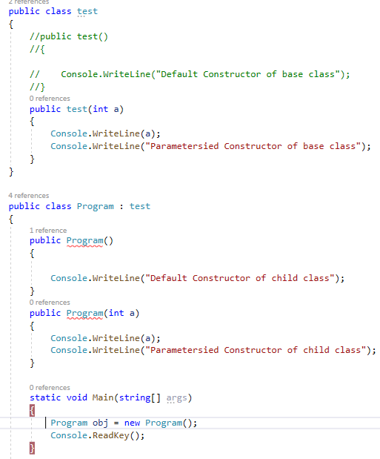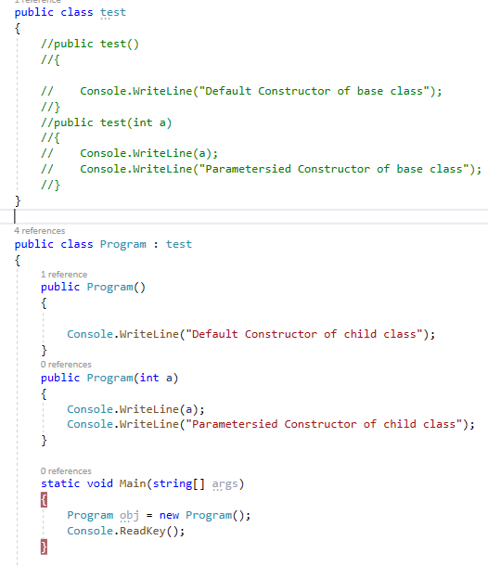

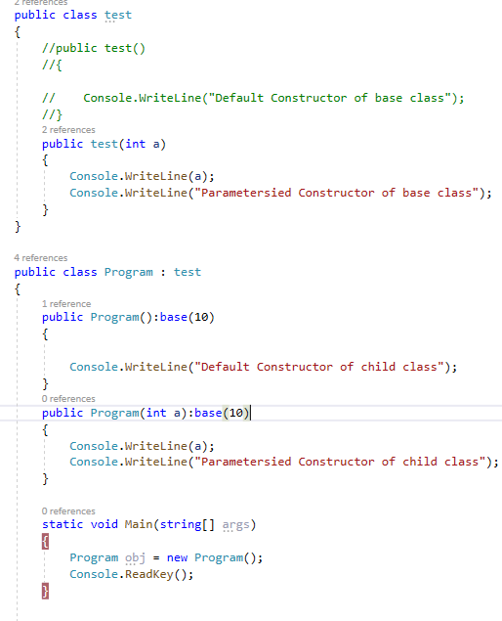

34. 

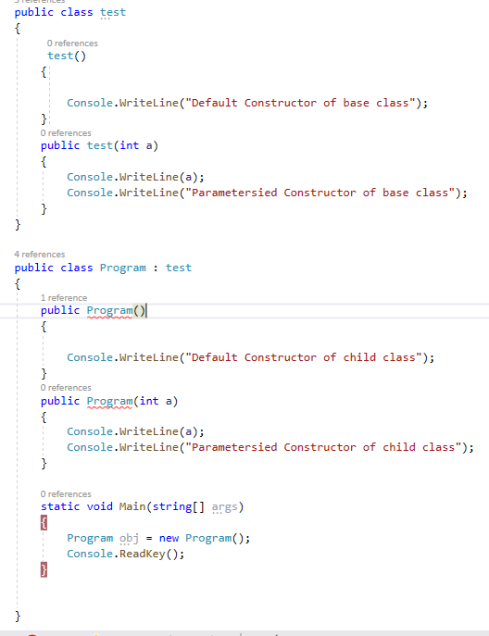 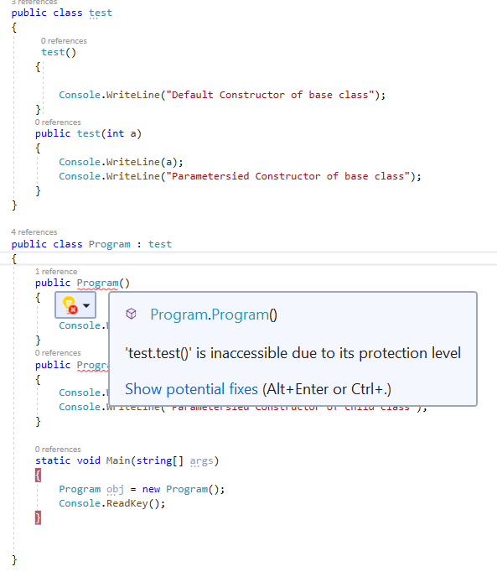

**35.Distructor**



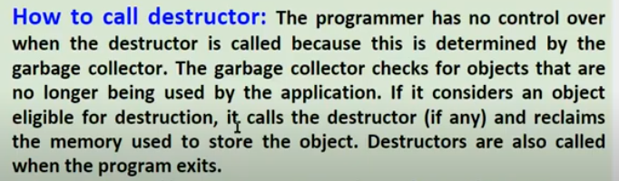

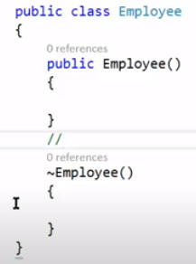

* 

No.

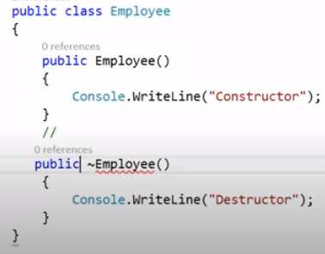

* No

.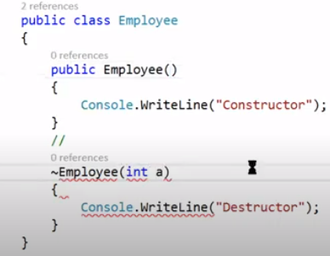

*  only once

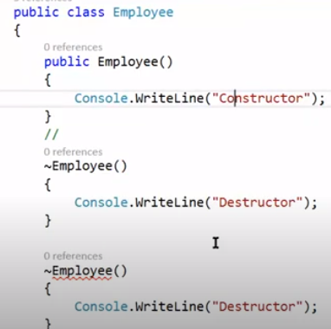

* No.
* 

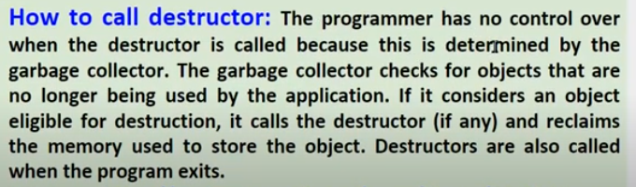

* 

It is not mandatory to define destructor as garbage collector automatically deallocates the memory.

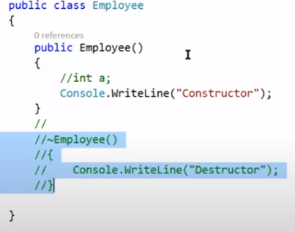

* 

It calls Finalize method

* We can explicitly call the Destructor by using:

GC.Collect()

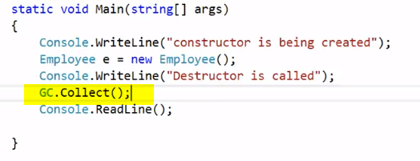 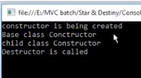

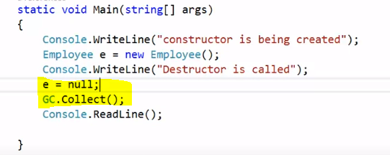 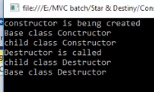

We have mentioned e=null because only then Destructor will be called when the object is no longer in use.

Note -> Hierarchy for

* Constructor -> Base then Child class
* Destructor -> Child then Base Class

As shown in pic above:

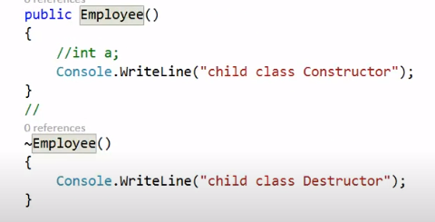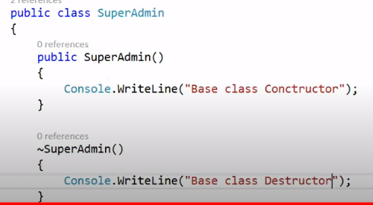

* 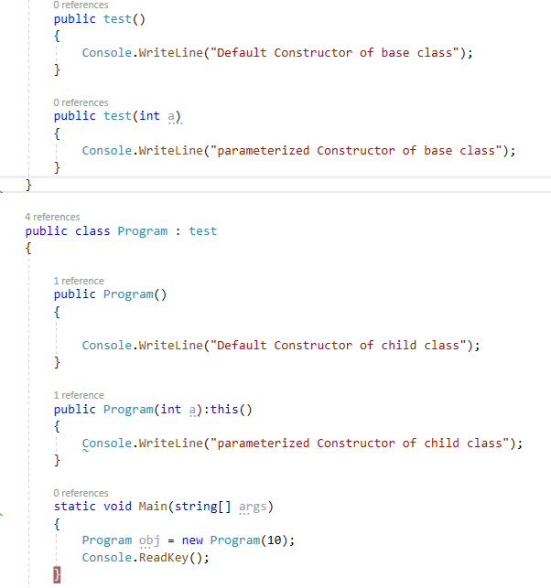

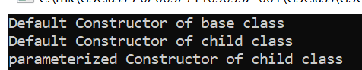

* 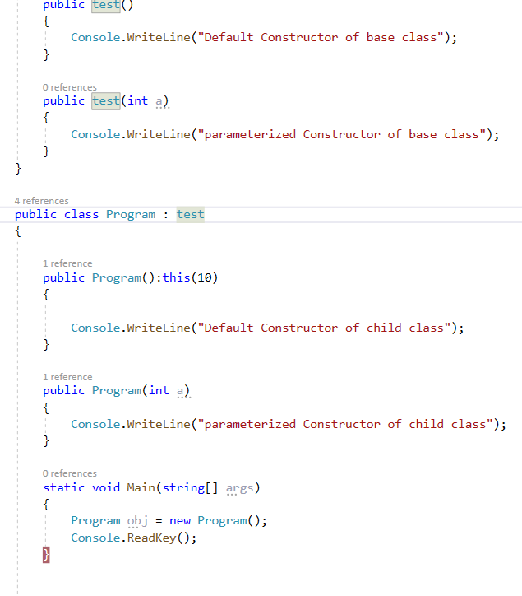

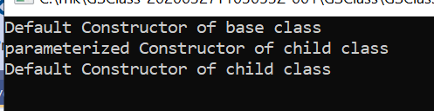

* Pic 2 is correct however in pic 1 it creates a deadlock .
* 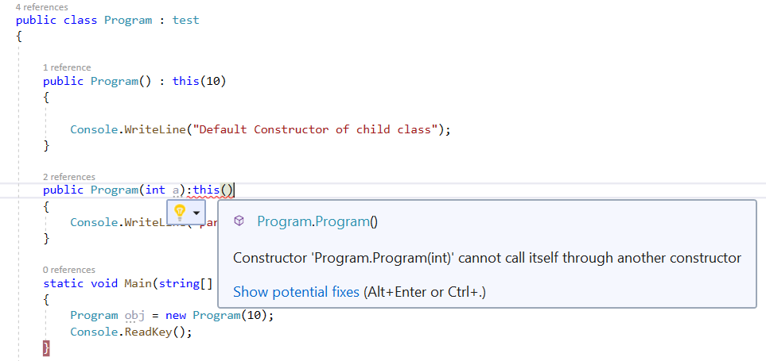
* 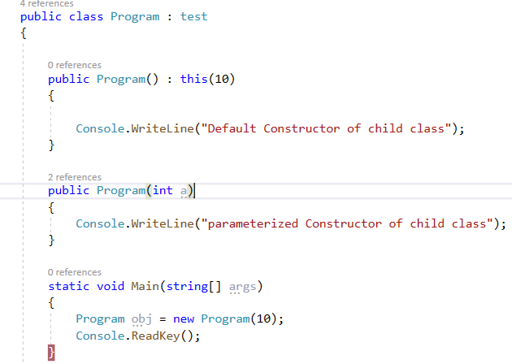
* 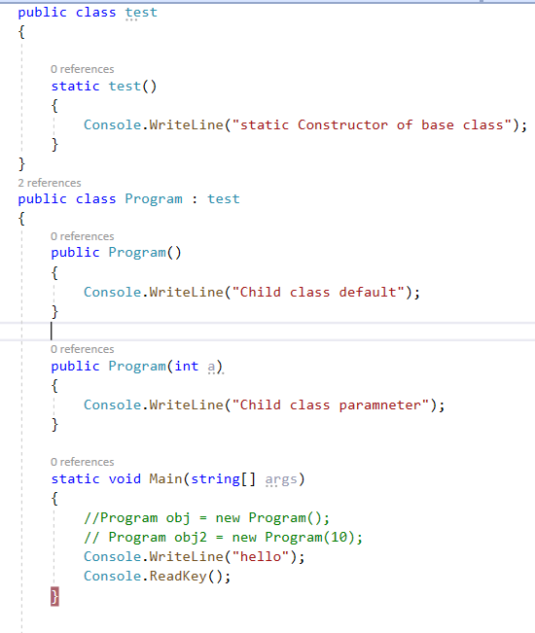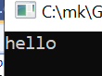
* 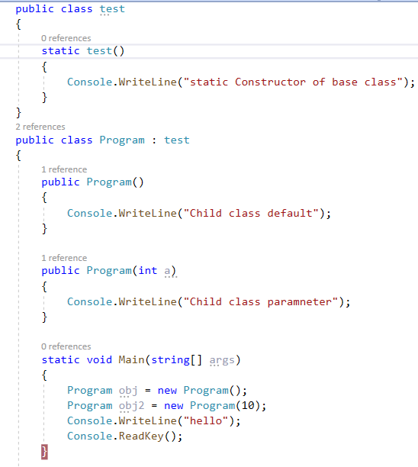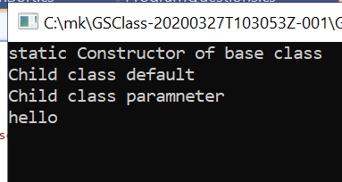

35.

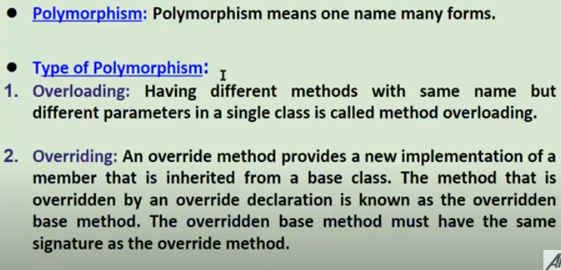

**Method Overloading**

* Same Name different Parameters (Note here return type makes no difference) New function will be with different number of parameters or same no. of parameters with different datatype. Plz see point2.
* What matters is order, number of parameters and datatype of parameters.

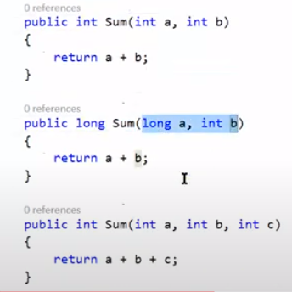

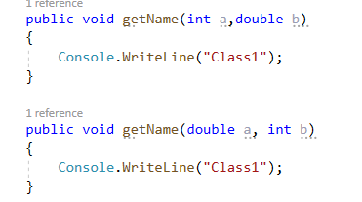

* Here the no. and type of parameters are same just the return type is different so it is incorrect that says therearetwo functionswith samename which is incorrect.

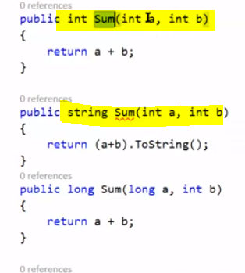

* This is correct as the names are different one with S and other with s but it is not Method overloading as overloading is with same name but here the name itself changes. So we can always have two functions with different names however it is not method overloading as method overloading is same name different parameters.

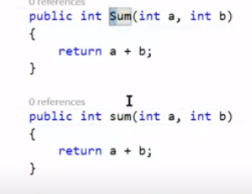

* 

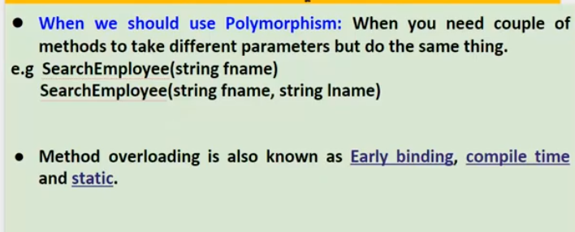

For example if we need to search an Entity sometimes on basis of Firstname and sometimes on the basis of Lastname then we can use method overloading.

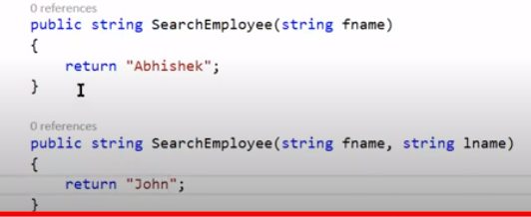

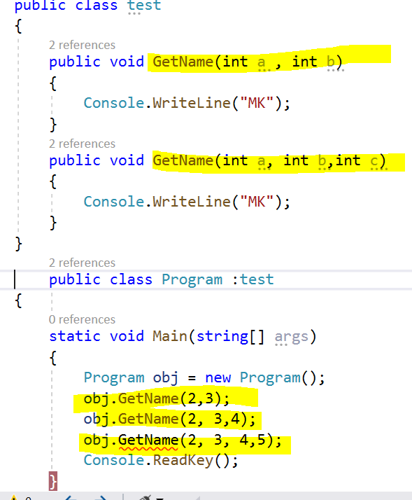

Now here as at the time of writing the code itself it decides which function call needs to be made and for obj.GetName(2, 3, 4,5);

There is no function written as the decision is taken at the time of wrtitng code it self this is called early binding/compile time.

**36. Method Overridden**

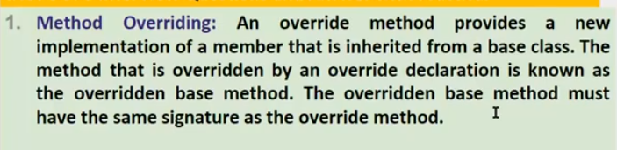

* 

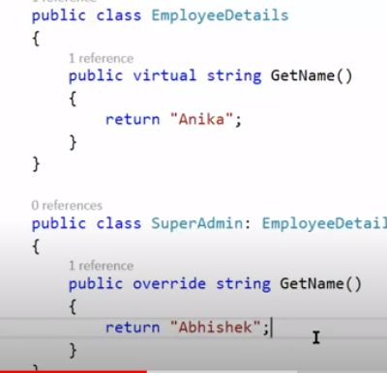

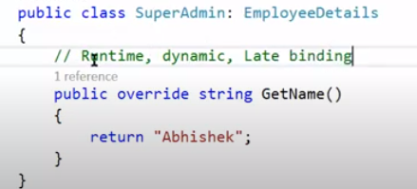

* **No**

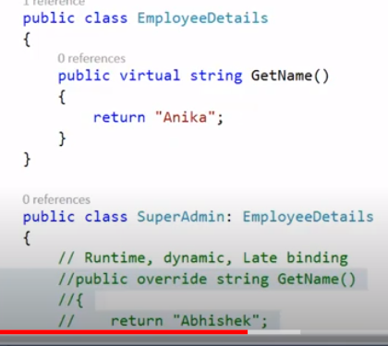

* 

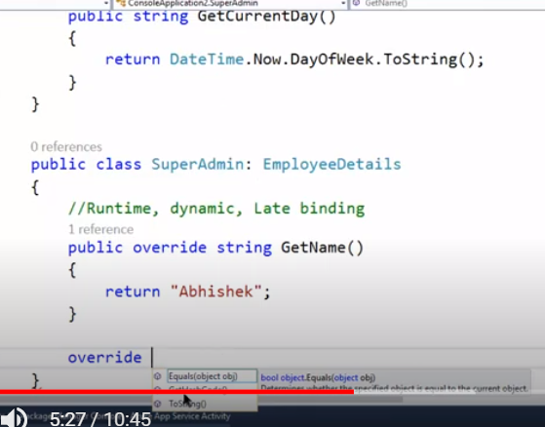

As we have written override method we can see that GetCurrentDay() is not available.

* No

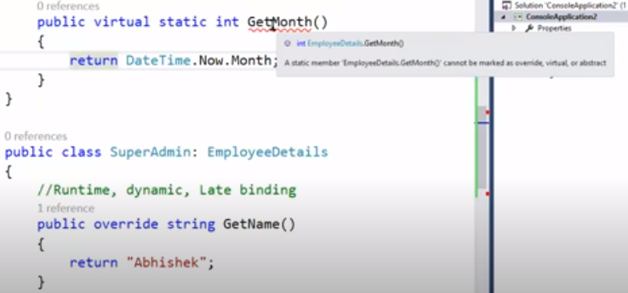

* Yes for all three.

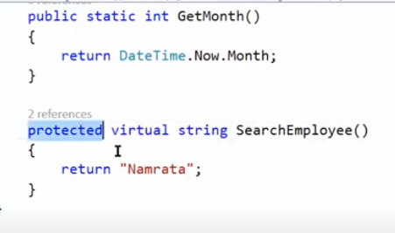

* 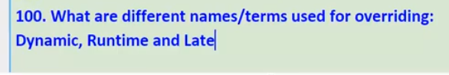
* 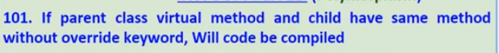Yes

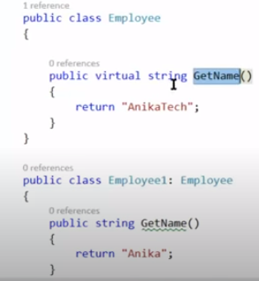

* No error on build is given. However if we mouse over the function name we get the following warming .

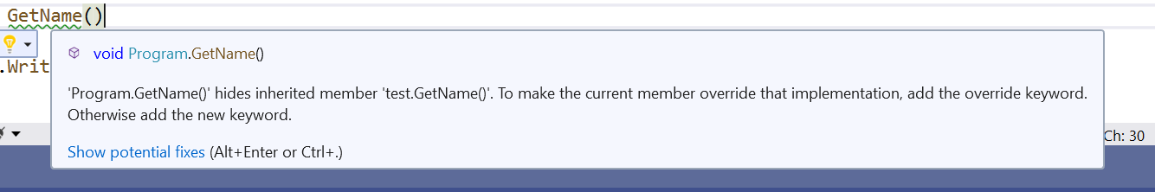

* 

It is used for method hiding.

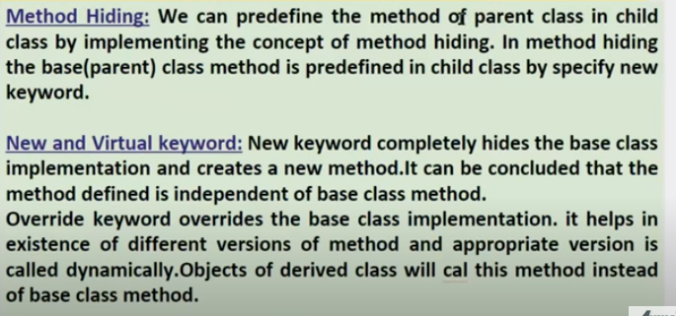

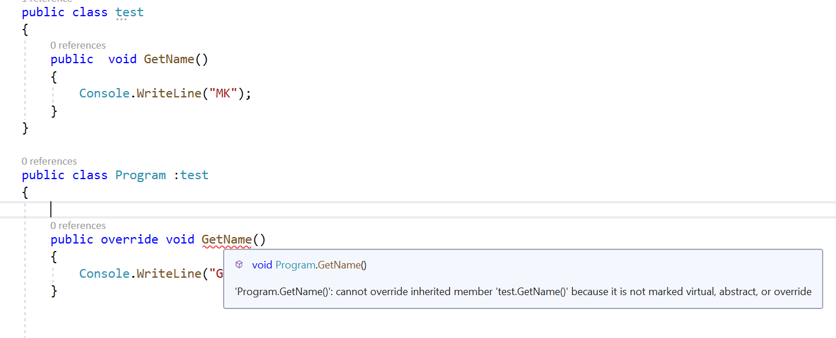

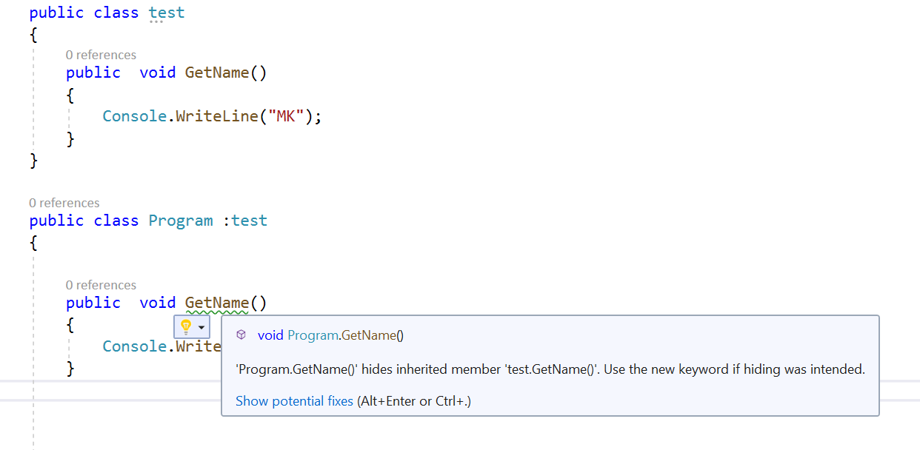

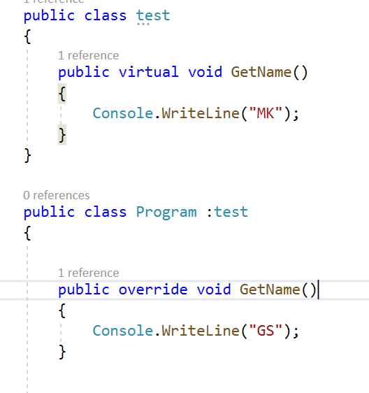

Here new is used for method hiding. And override is used for method overriding.

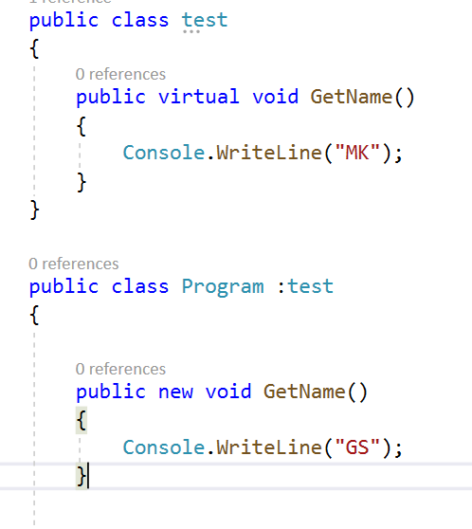

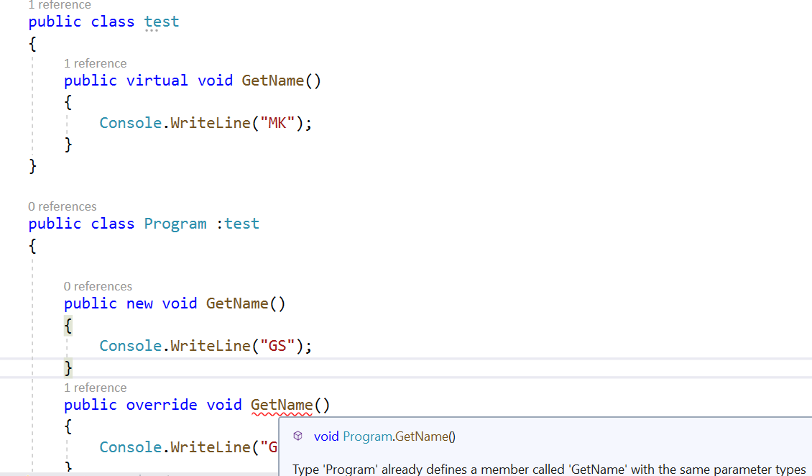

* 

Used to implement method hiding.to hide the base class method.



Here we can see that virtual class can be overridden in the child class employee1 and can be again overridden in the further derived class employee2.

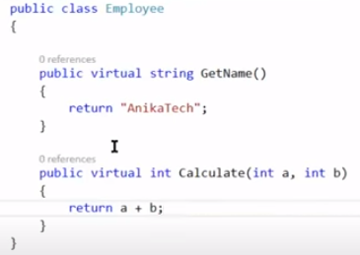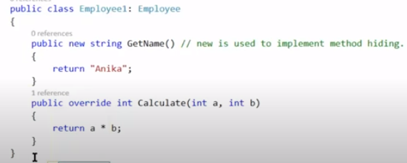

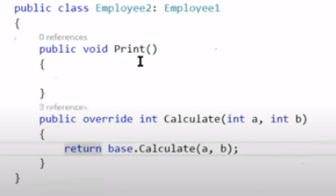

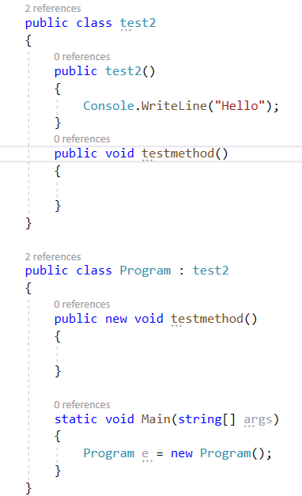

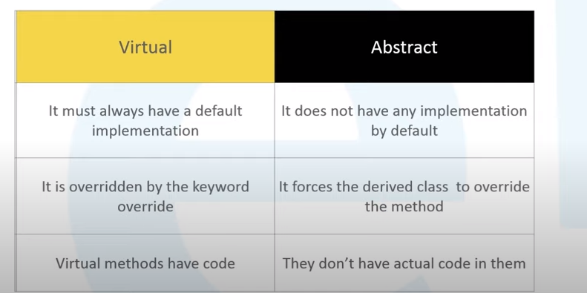



To prevent the override of calculate method by employee2 Class we can mark the method in employee1 class as sealed. Note we can not use the sealed keyword with normal methods we can us it with override method.

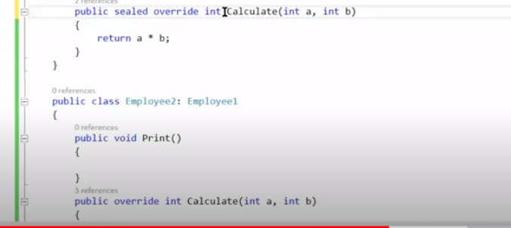

This will give complie time error. As we have marked the method as override in Employee2 class.

37. 





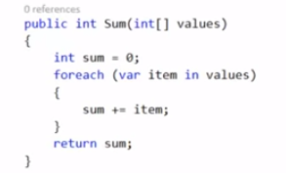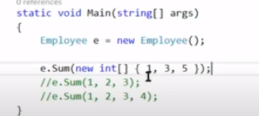

In above pic there is only one parameter however in pic below there is more than one paratemeters that is why it is method overloading.

When we pass this we have to create an array only then we can call Sum function.

Now using param key word we can in a way achieve method overloading.

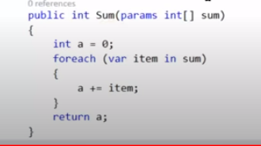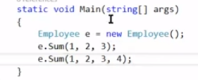

So this is method overloading where array can accept any no. of values. Same method name with different parameters.

* It should be at last.

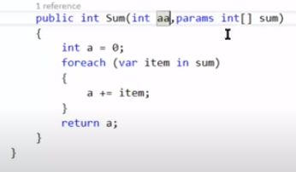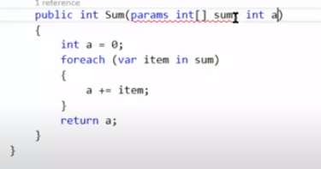

37. 

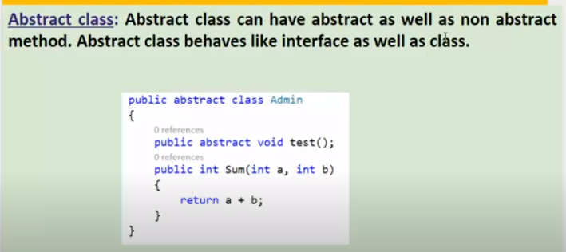

* No

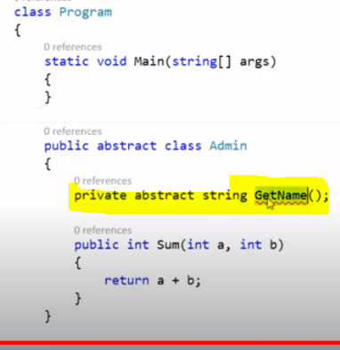

* No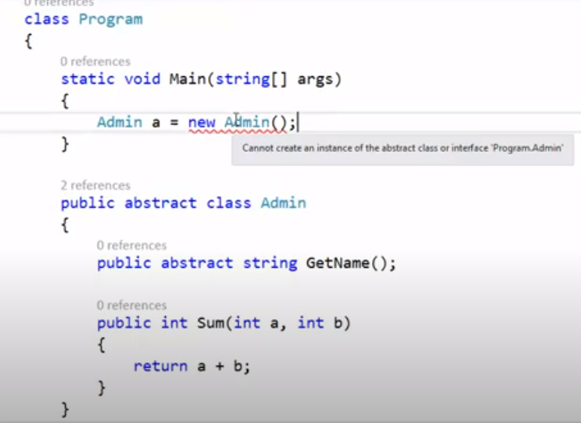
* yes

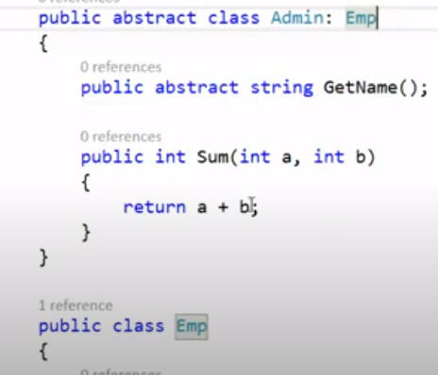

* 

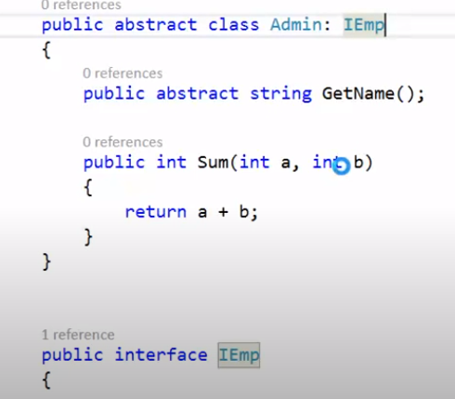



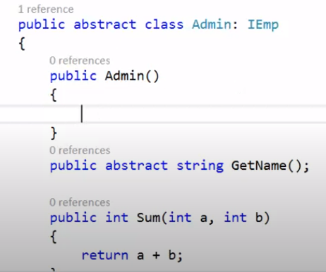

* 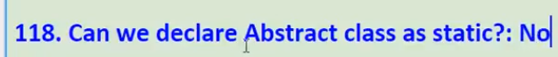

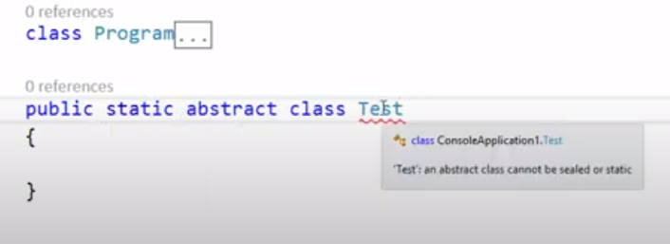

* 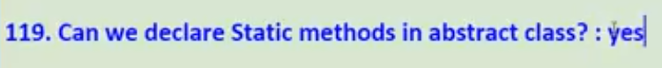

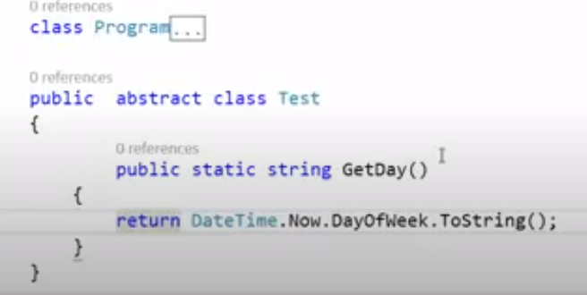

* 

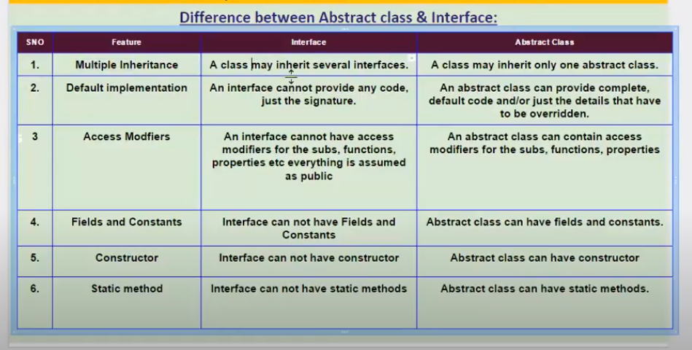

* Abstract class can have constructor & destructor where as an interface can have neither.

* Cannot inherit multiple abstract classes.

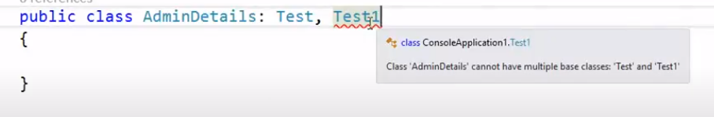

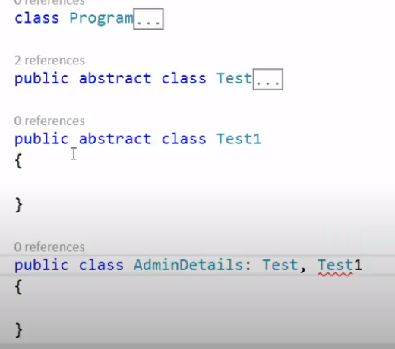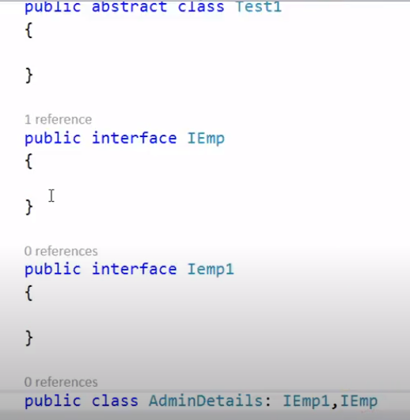

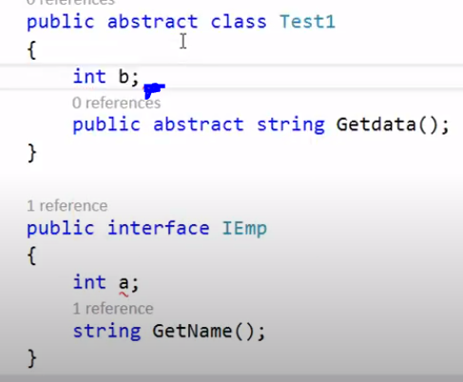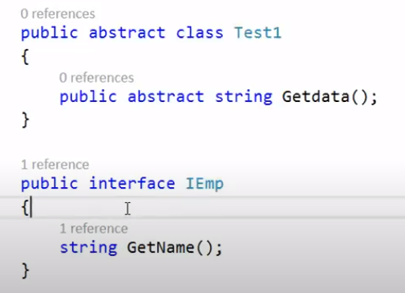

40. 

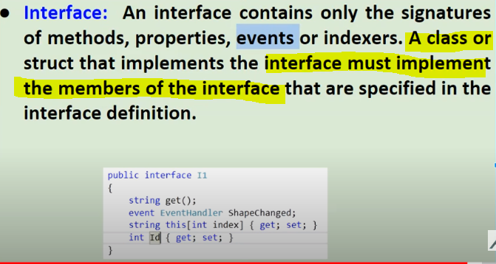

In interface we only have the signature of the method and no implementation. By default interface is Internal. Had it been public the interface would have been accessible outside the project.



In different project we cannot access the interface without public keyword.

Pics 2

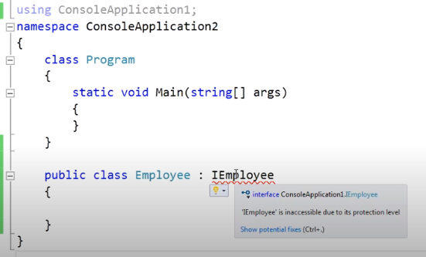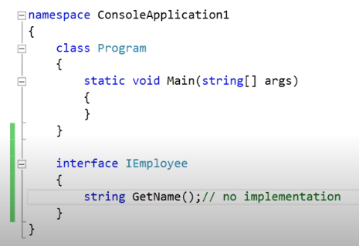

However as shown below in same project we can access the interface without public keyword this says that by default interface is Internal Just like class. Class is also internal.

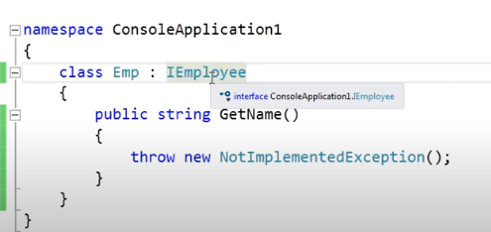

No

* By Default all the methods in an interface are public so we need not provide the access modifiers.

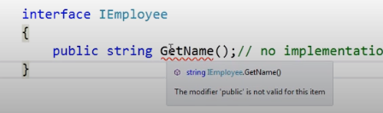

* No.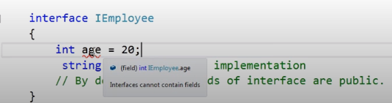
* No.

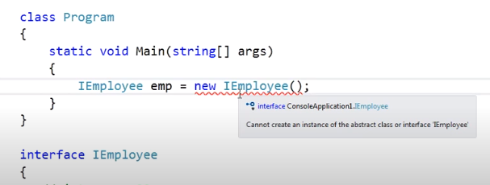

* No.
* Yes

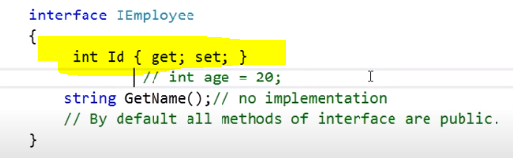

* Yes

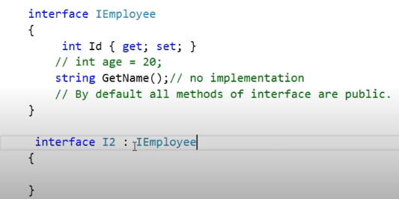

* No.

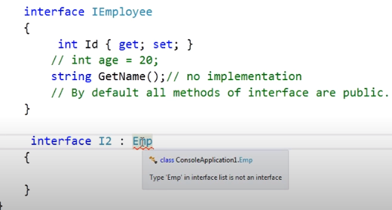

* 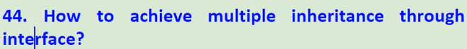

C# does not support multiple inheritance through Classes we cannot inherit two classes but we can inherit two interfaces at a time.

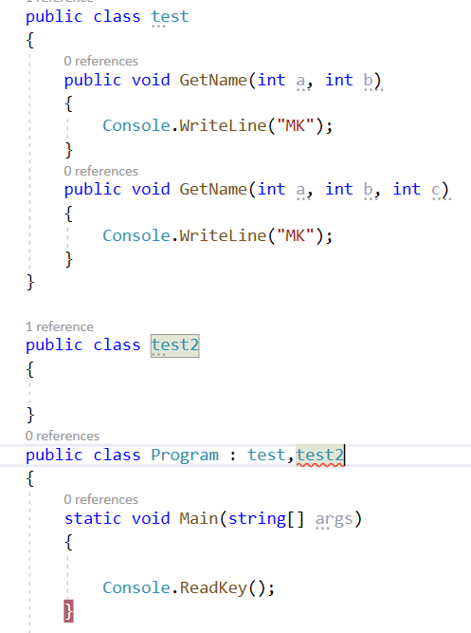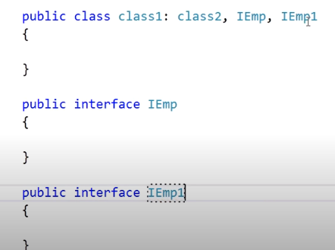

Order matters. Class has to come before interface.

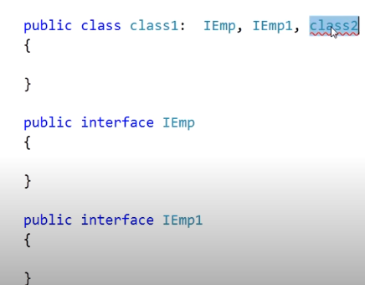



Its mandatory to implement the methods od interface in the derived class.

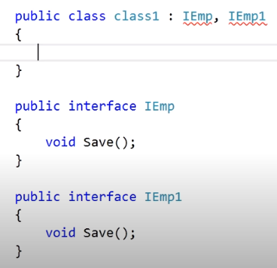

When we have same method name in two interfaces then we can use the explicit implementation

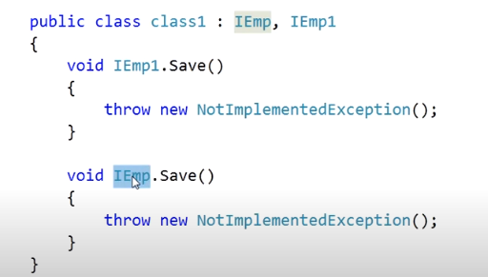

Yes



Implicit implementation of interface method and their calling.

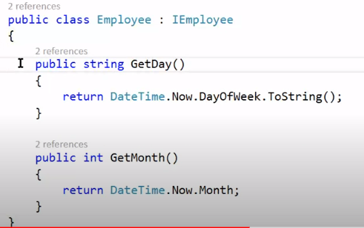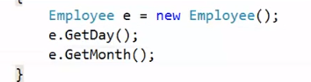



Explicit Implementation and their calling. In this case method cannot be called by object of class it needs to be called by object of interface new class(refer below pic)

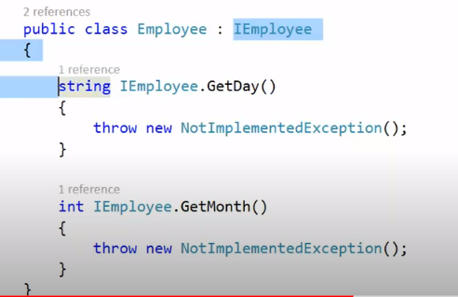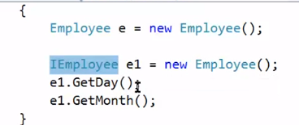

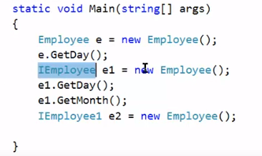

* All the abstract methods of both interface and class must be defined in the derived class.

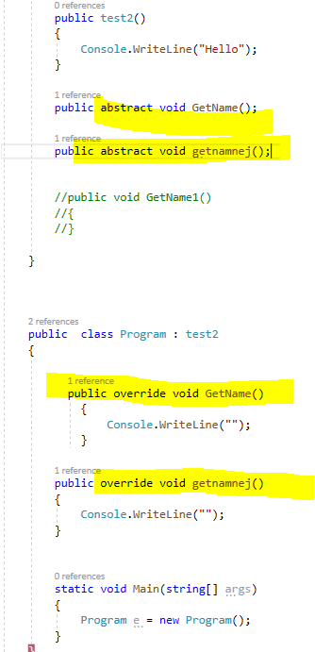

* Can abstract have only abstract methods. Yes.

It must have atleast one abstract method to call a class as abstract.

It can have only abstract methods.

It can have abstract and non abstract both methods.

But It cannot have only non abstract methods becz as wesaid it must have atleast one abstract method to vcall a class as abstract.

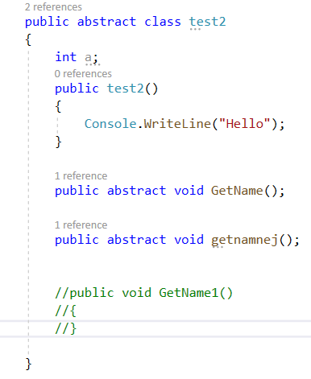

Refer below pic When I tried to do this it still gave error that it is must toimplement abstract method as new keyword hid the abstract method and testmethod function is treated as a new function in child class. And as it is necessarry to define abstract method in child class I must

I must give its definition by override keyword.

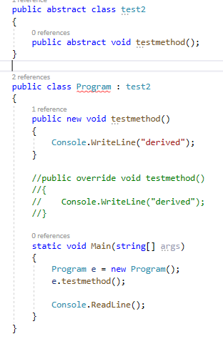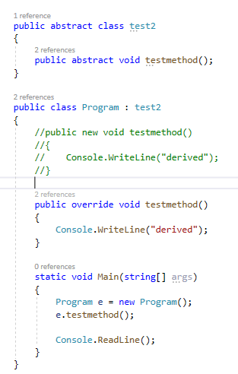

I had to comment new keyword method as there can not be new and override for same method name togther .

* Interface

Interface can have only signature of the methods. It cannot have defualt methods

It can also exist without any method as shwon below.(empty interface)

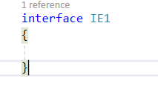

* 

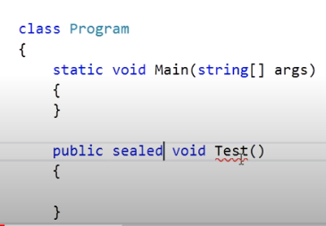

* 

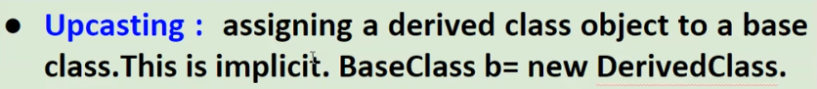



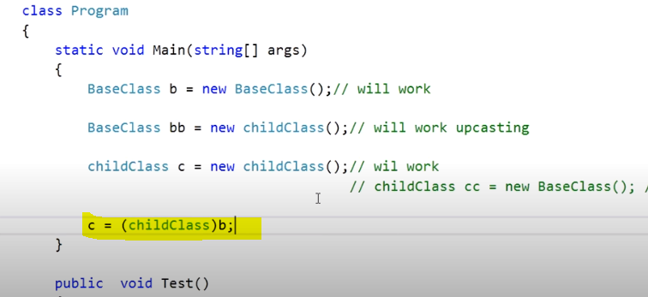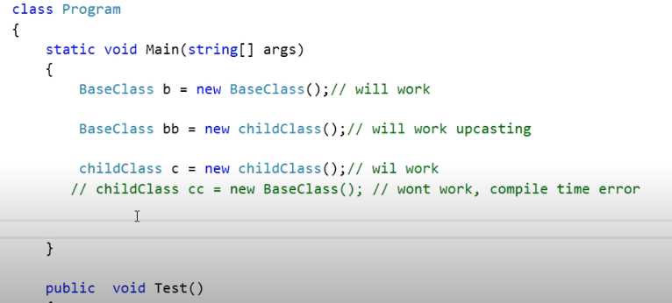

Now let’s convert base class to child class. Note it will not give compilte time error.(error on build) but it will give runtime error.



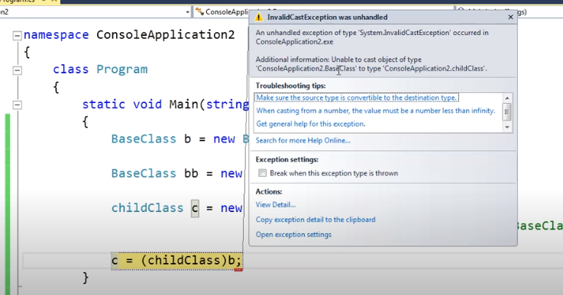

So this is downcasting and it won’t work.

* If there is a test() method in both child and base class then in each case which method will be callled.

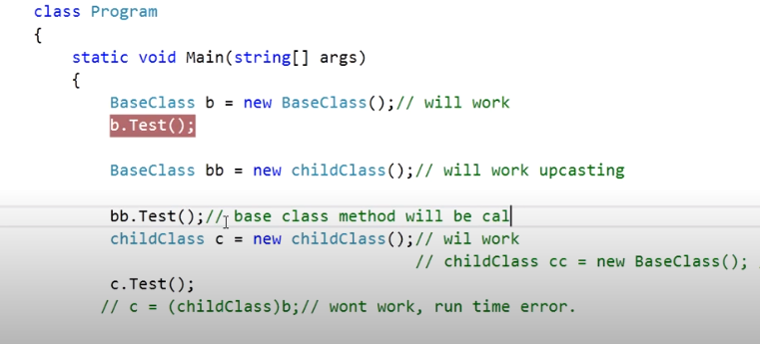

In b.test() -> baseclass method is called.

bb.test() -> baseclass method is called.

c.test() -> childclass method is called.

* Difference between Method overriding and method hiding comes into play when there is upcasting.

i.e. BaseClass bb = new childclass();

How to read this -> eachtime just see on the left hand side whateever the type is on left hand side – BaseClass/Childclass that class’s function will be called.

> Incase of overriden it will got the base class function it will see there is virtual written over it it will go and call the overriden mnethod no matter the type was base class.

i.e. BaseClass bb = new childclass();

Here the BaseClass bb = new childclass();

Obj2.GetName() will call the base getname function class1 getname function as the type is class1/baseclass

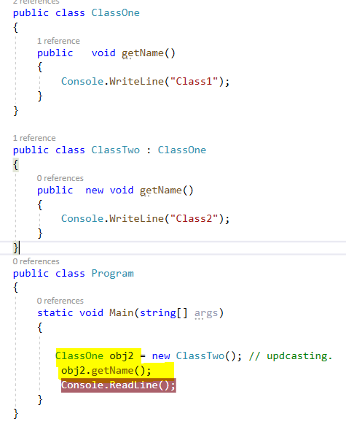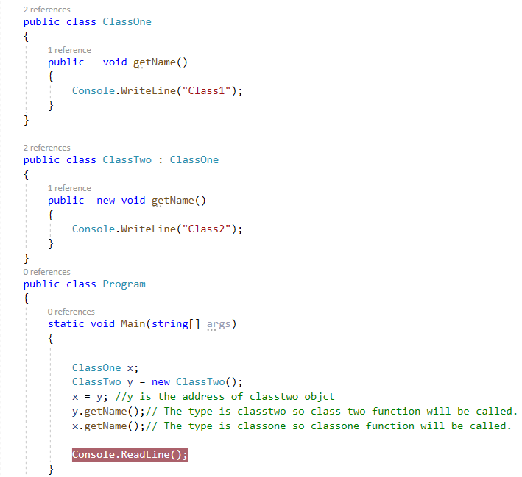

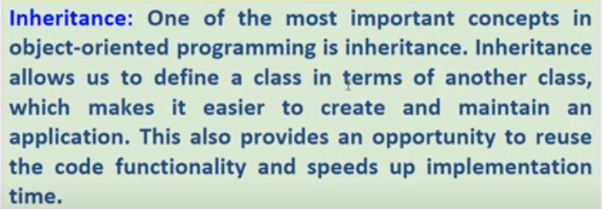

Inheritance is for Cod reusability



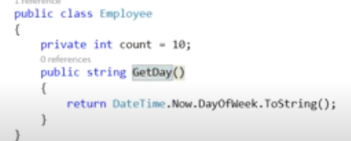

Most of the people say that by creating the object of base class we can use the base class method. Which is wrong we have inherited the Employee class so we can directly use the base class method or we can use base.Getday() or this.getday();

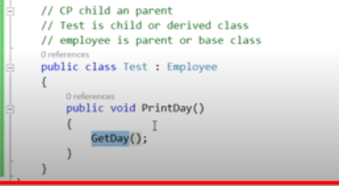 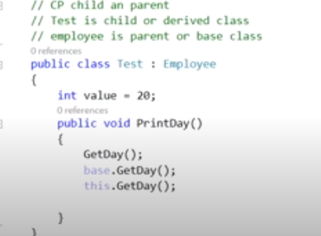

* No. As discussed previously. C# does not support multiple inheritance.We can achieve multiple inheritance via Interface.
* No

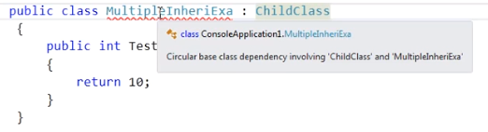 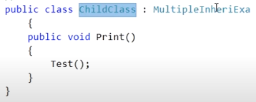

* 

Using Sealed Keyword.

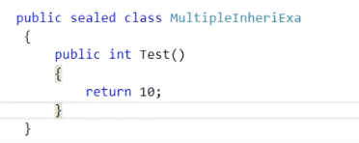 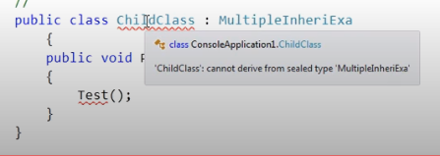

* 

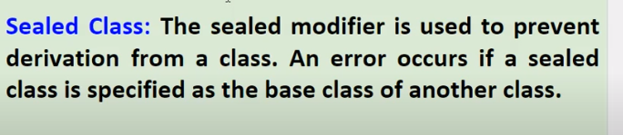

* Yes

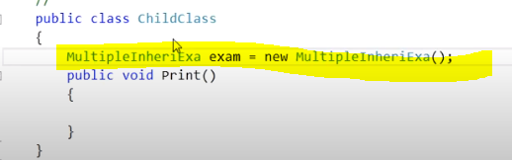

* No

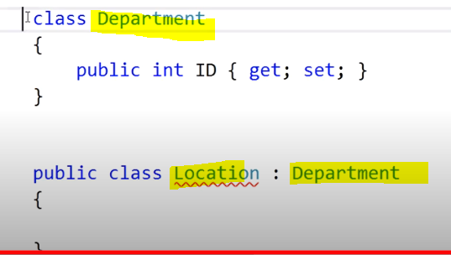

But this is possible

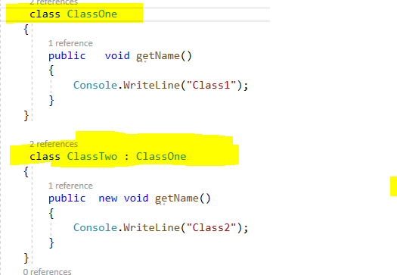

* 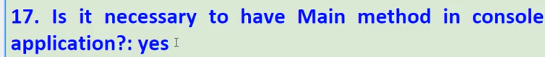

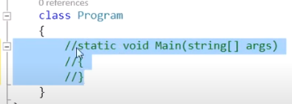

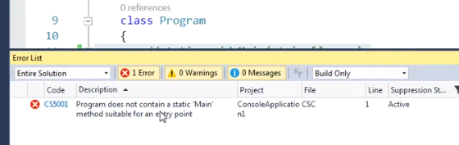

* 

Main Method is the starting point



* 

Comiple error if we comment the main method and build it.

* 

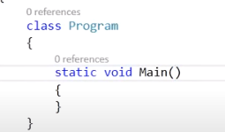This will compile correctly.

* No.



* 

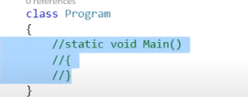 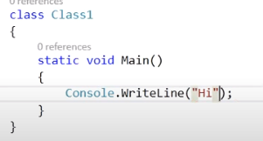

* Can we explicitly call main method again?

Yes. We can also call it from some other class but then it says the main method is inaccessible due to its protection level so we will have to mark static void main(string[] args) as public. Refer pic 2

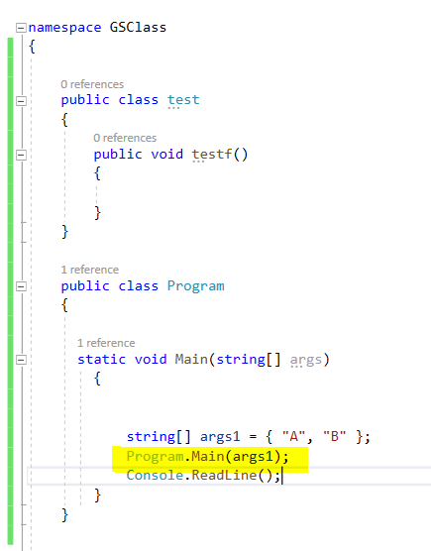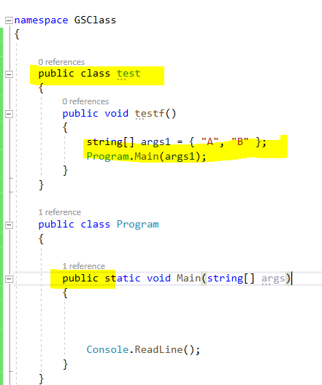

* 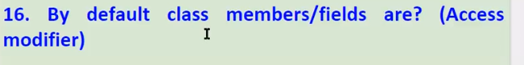

By default class is Internal.

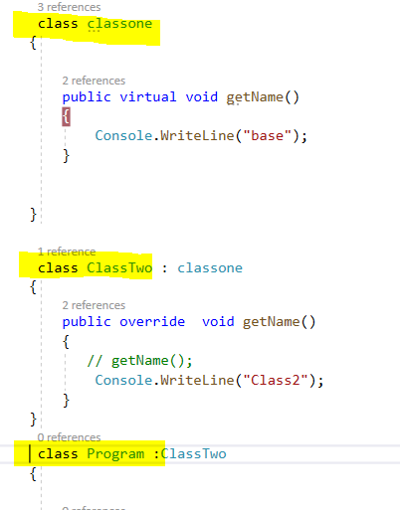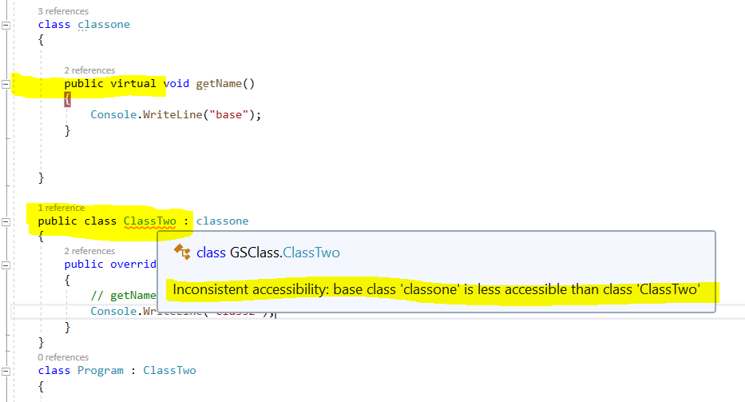

By default properties or members of the class are private.

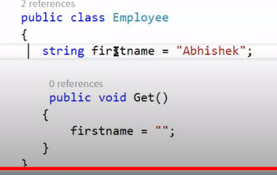

First name is not available in emp. As it is by default private. And private member can only be

Accessed with in the class and not outside the class.

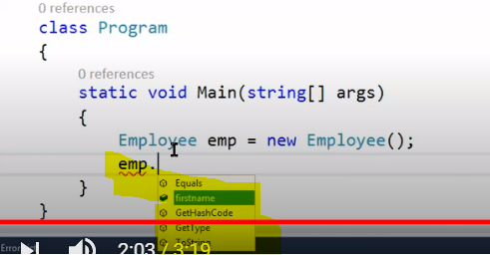

* 

We cant use special charatcters or just numbers to name a class. We can use only one special character to name a class i.e.” _Admin”

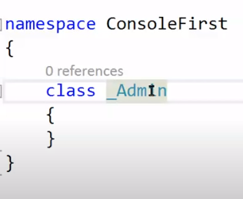

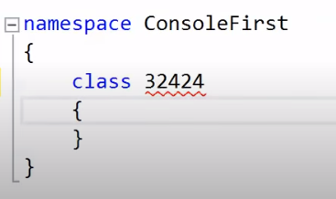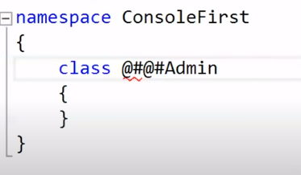 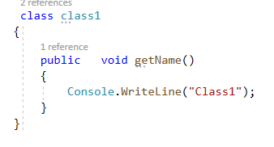

* 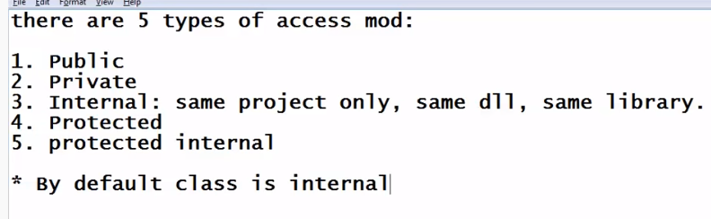



* We cannot declare the class as private,protected or protected internal.Either we can use Internal keyword or public keyword. And by default the class is Internal.

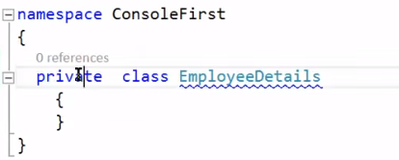 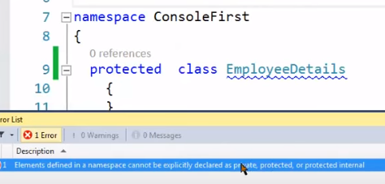

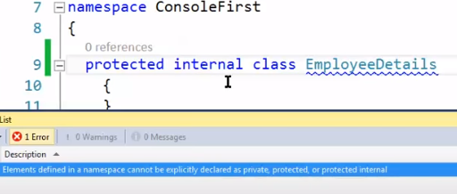



Private members can be accesd within the class.

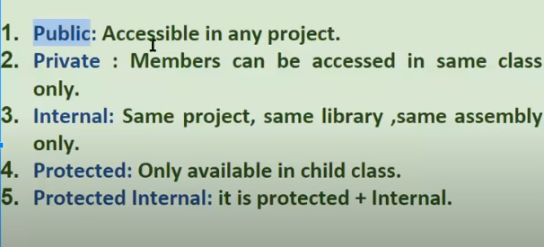

Private members are accessible with in the same class. and not outside for ex:

Protected are accessible with in child class and not outside for ex:

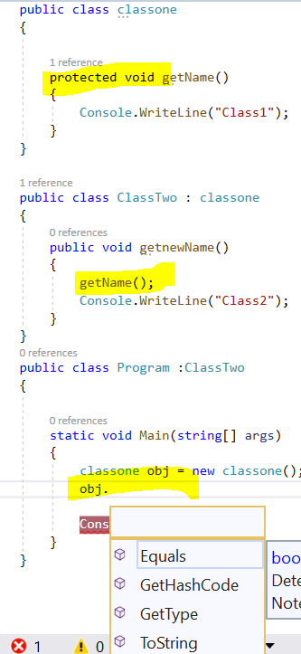 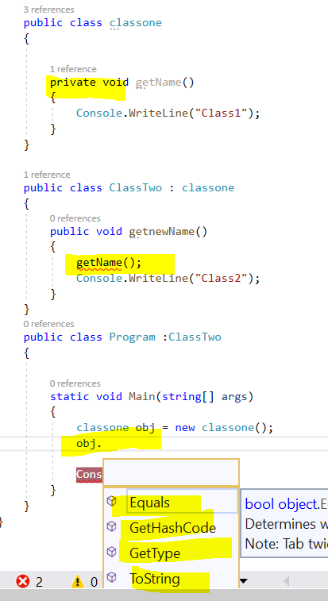

* 

Protected vs Protected Internal

* We cannot access the protected members by creating object.We can use them only in child class(Either in same project or outside of the project also but only through inhertance not by creating object.).Note(Private can niether be used in child class nor by creating the object in main method.)

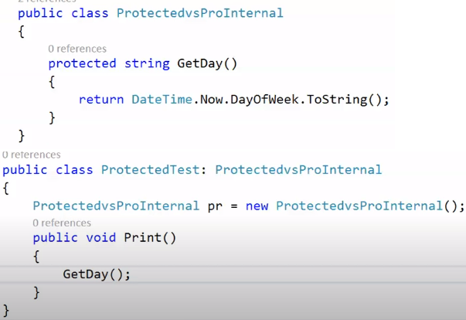

* Protected internal-> It has both the properties protected + internal.

Due to being protected -> It can be used through inheritence .It can be used in child class with or without creating object. Because it is protected it can be used via child class and because it is internal we can call it by creating object also .(With in the same project)

Outside the project -> As we know it is internal so it will not be accessed by creating the object but because it is proected so it can be used by inheritance i.e in the child class.

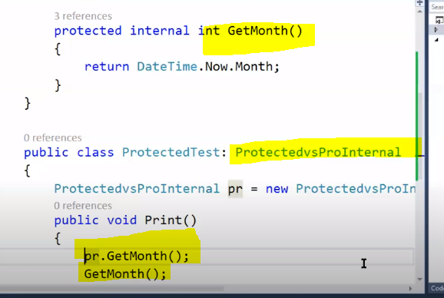

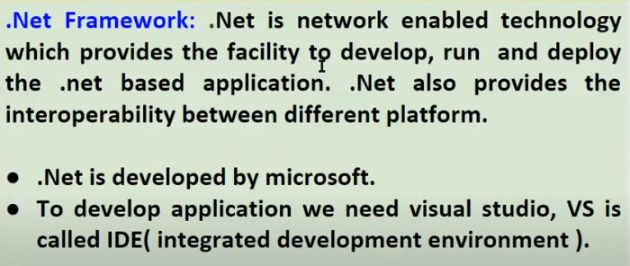

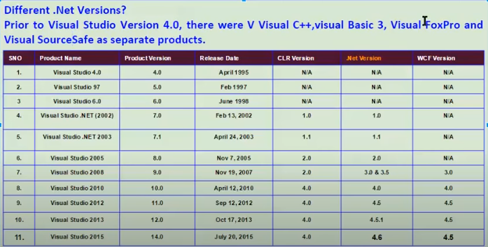

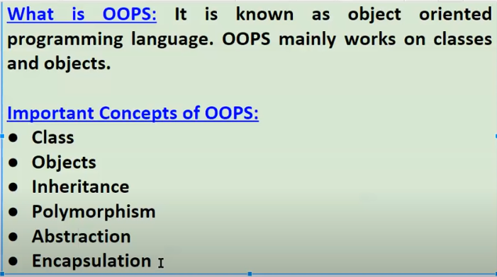

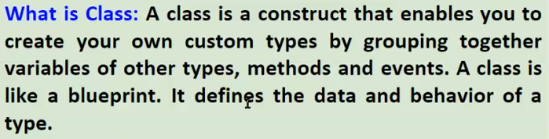





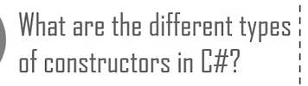 Default,paramertized copy,static

and private constructor

